HTML5 and CSS3 assignment:

Create a web page with HTML5 and CSS3:

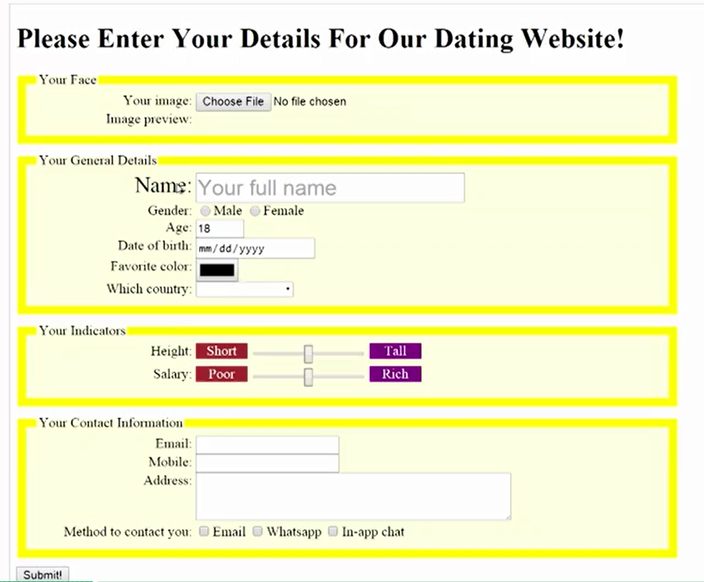

Requirement:

Create four groups. These all field set with legend.

Group example:

<form>

<fieldset>

<legend>Personal Information</legend>

First name? <input type="text" name="firstName"> <br>

Last name? <input type="text" name="lastName"> <br>

</fieldset> <br>

<fieldset>

<legend>Favourite Things</legend>

Favourite cartoon? <input type="text" name="favCartoon"> <br>

Favourite pizza? <input type="text" name="lastName"> <br>

</fieldset> <br>

</form>

1. Your face section:
   1. ~~Handling file upload: <input type=”file”>, you should be able to preview the uploaded image on the web page.~~
   2. Same as uploading a image, upload audio and video on the page (Bonus points)
2. Your General details:
   1. ~~Show “your full name” in the textbox as the tooltip~~
   2. ~~Gender~~
   3. ~~For Age,~~ **~~use a number input~~** ~~field as a spinner which you have up and down arrow at the right of the textbox to increase or decrease the number value (Hint: input type:~~ Numbers)
   4. For Date of birth field, see below: (Hint: input type: Date)



* 1. ~~Favorite color: click on the color box, it should show the color picker on the page.~~

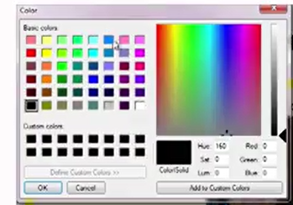

* 1. ~~Which county: it will show a list of countries in the drop down. You can hardcode some values. (hint: input Attr datalist)~~

1. ~~Your indicators:~~
   1. ~~Height and Salary should be sliders. (Hint: input type Range)~~
2. ~~Your contact information:~~
   1. ~~It should have Email, Phone and Address~~
   2. ~~Method to contact to you.~~
3. ~~Validation requirement:~~
   1. ~~Make all the input fields as required fields. (Hint: input Attr: Required)~~
   2. ~~While typing in the email input, validate if it is a valid email address. (Hint: Input type: Email)~~
   3. ~~While typing in Phone input, only numbers are allowed (Hint: Input type: Phone)~~
4. Style requirement:
   1. ~~For each group, highlight the border and make the background color to light yellow.~~
   2. If you mouse over the labels or the input controls, they will get larger. (see “Name” and name textbox in the screenshot above)
   3. ~~Be creative, create your own style and make the web page look great! (Bonus points)~~